*Coursework 1: Predictive Data Mining Group Project*

**Project Brief**

**Group Name:** Troublemaker

**1. Team Members**

We are team of five members as following:

|  |  |  |
| --- | --- | --- |
|  | **Full name** | **Email** |
| 1 | Lu Yang | [ly4n17@soton.ac.uk](mailto:ly4n17@soton.ac.uk) |
| 2 | Jinmu Liu | jl12m17@soton.ac.uk |
| 3 | Jiachen Li | jl4g17@soton.ac.uk |
| 4 | Qin Yu | qy2a17@soton.ac.uk |
| 5 | Yue Wang | yw3y17@soton.ac.uk |
| 6 | Junjie Lu | jl9n17@soton.ac.uk |

**2. Description**

***Description:*** The toxic comment classification problem is from Kaggle which provides various data mining competitions. We aim to detect and classify the offensive comments by their contents. Firstly, we are planning to do the binary classification and distinguish whether toxic or not. After we get the result, we will continue to explore the extent of the toxic comments and determine its category (see Data Section). The main algorithms we plan to use are Naive Bayesian classification, random forest, neural network and support vector machine. Finally, we will compare the results of these algorithms and give an optimal method to implement multi-classification of toxic comments.

**3. Data**

**Training set:** The training set contains 159571 observations and 8 columns ( id, comment text, toxic, severe toxic, obscene, threat, insult, identity hate) which marks the comment in the last six columns with 0 or 1 (figure 1), which means the comment is considered to be offensive or not or which kinds of offence. And the comments can belong to multiple categories of offence.

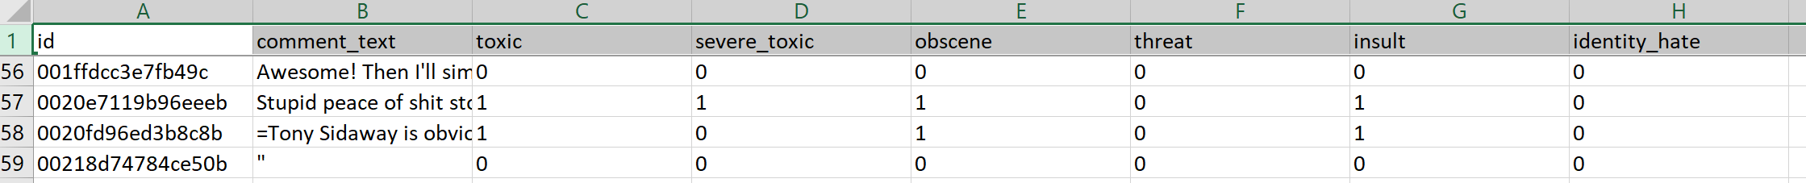

Figure 1: Training set

**Test set:** The test set is consist of 153164 observations and 2 columns, the id and text.

**3. Git Repository**

https://github.com/yeunglo/DataMining-Group-Project

**4. Kaggle Challenge**

https://www.kaggle.com/c/jigsaw-toxic-comment-classification-challenge